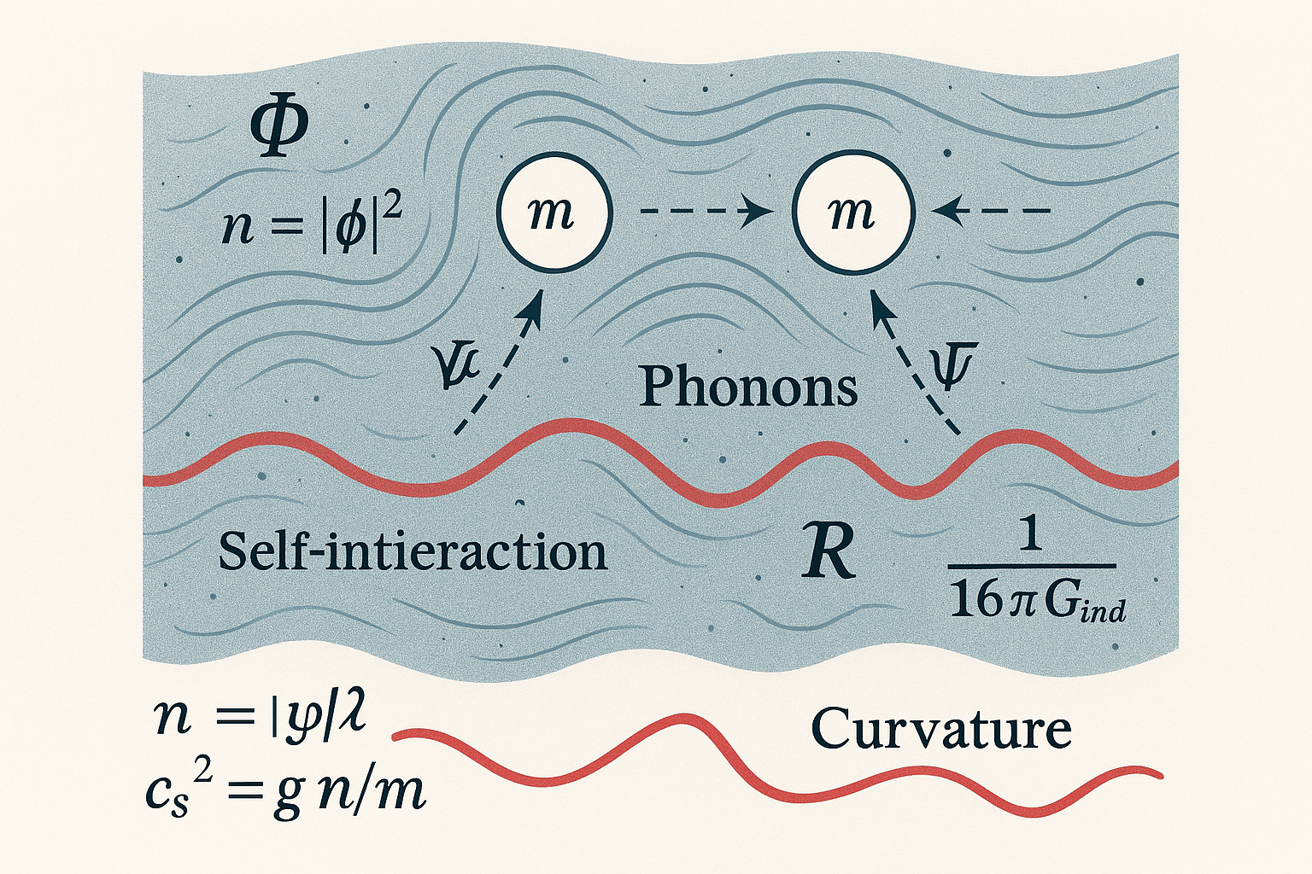
- Note, the Symbol: $n=∣ψ∣^{2}$ is shown incorrectly in the diagram above. Replace $Φ with ψ$

Here’s a simple, visual way to read the diagram and map the symbols to the picture:

How to read the picture
1) The background “sea” = the field that fills space
- What you see: A calm, bluish medium with gentle lines and dots.
- Symbol: $Φ$(phi)
- Plain meaning: The universe-filling “stuff” (a quantum fluid/BEC). At every point it has an amount.
Local amount (density):
- Symbol: $n=∣ψ∣^{2}$
- Plain meaning: How much of the fluid is at a spot. More $n$= denser medium.

2) The white spheres = bits of matter
- What you see: Two white circles labeled $m$.
- Symbol: $m$(mass)
- Plain meaning: Objects (particles, matter clumps) sitting in the fluid.
Why they feel each other:
- Dashed arrows indicate an effective pull that appears because the medium is disturbed between them.

3) The small wavy arrows = ripples in the medium
- What you see: Little dashed, curved arrows pointing from matter into the sea.
- Name: Phonons (sound-like ripples)
- Symbols nearby: $ψ$(the condensate wave), $c_{s}$(sound speed)
- Plain meaning: When matter is present, it pushes the medium. The medium pushes back through ripples; this response can transmit forces.
Stiffness/response speed:
- Symbol/formula: $c_{s}^{2}=g n/m$
- Plain meaning: The stiffer/denser the medium (big $g$or $n$), the faster ripples travel.

4) The red wavy line = curvature / bending
- What you see: A red curve passing through the scene and again at the bottom with “Curvature.”
- Symbol: $R$
- Plain meaning: A single number that summarizes how space(-time) is bent there. In this picture it reminds you that the medium’s global response looks like curved geometry.

5) “Self-interaction” label inside the sea
- Symbol in the action: $λ$(or $g$in the fluid form)
- Plain meaning: How strongly the medium resists being compressed; it sets the pressure and therefore the sound speed.

6) The fraction $\frac{1}{16π G_{\text{ind}}}$
- What you see: Printed near the curvature symbol.
- Plain meaning: This is the stiffness of spacetime in the large-scale theory—the thing we normally call Newton’s constant $G$, but here it’s induced by the medium’s micro-physics (how many ripples there are, how they couple, and the high-energy cutoff).

What the whole picture is saying (in words)
- Background: Space is modeled as a smooth quantum medium $Φ$with density $n$.
- Matter: When masses $m$sit in it, they displace the medium.
- Ripples: The medium answers with phonon ripples that carry the response; their behavior depends on the density $n$, interaction $g$/$λ$, and sound speed $c_{s}$.
- Curvature: Coarse-grained, that response looks like curved spacetime (symbol $R$).
- Gravity’s strength: The overall “stiffness” multiplying $R$(drawn as $1/(16πG_{\text{ind}})$) is not inserted by hand—it can emerge from the microscopic properties of the medium (how many modes there are and their cutoff), which is the essence of the “induced gravity” idea.

Quick legend (plain-English lookup)
- $Φ$: the everywhere-present field (the sea)
- $ψ$: the condensate wave describing that sea locally
- $n=∣ψ∣^{2}$: local amount (density) of the sea
- $m$: mass of a particle/object (the white spheres)
- Phonons: little ripples in the sea that transmit forces
- $c_{s}$: sound speed of those ripples (how stiff/quick the sea reacts)
- $g$or $λ$: interaction strength of the sea (sets pressure/stiffness)
- $R$: curvature — the large-scale bending that results from the sea’s response
- $1/(16πG_{\text{ind}})$: overall stiffness of spacetime emerging from the sea’s micro-physics

A. The “relativistic” starting point (the field and spacetime)
$Φ$(capital phi)
- What it is: A field that fills space and time; at every point you can think of it as a number (or a complex number).
- Why we use it: It’s our mathematical stand-in for the “stuff” that can form a Bose–Einstein condensate (BEC) on cosmic scales.
$g_{μν}$(metric of spacetime)
- What it is: The object that encodes distances and times in curved spacetime (general relativity’s “ruler and clock”).
- Why we use it: To describe physics in a possibly curved universe and to couple the field $Φ$to gravity.
$∇_{μ}$(covariant derivative)
- What it is: A derivative that knows spacetime is curved, so it “subtracts out” curvature effects when differentiating.
- Why we use it: Ordinary derivatives don’t behave nicely on curved spacetime; this one does.
$R$(Ricci scalar curvature)
- What it is: A single number at each point that summarizes how spacetime is curved there.
- Why we use it: It’s the core “curvature” term that appears in Einstein’s theory and in many effective actions.
$\sqrt{-g}$(volume factor)
- What it is: A multiplier that correctly measures volume in curved spacetime when integrating.
- Why we use it: Without it, integrals over space and time wouldn’t represent true physical volumes/areas in curved geometry.
$S$(action)
- What it is: A single number you get by integrating the Lagrangian over all space and time.
- Why we use it: The “principle of least action” says the real world follows the path that makes $S$stationary; it’s how we get equations of motion.

B. The parameters you saw next to $Φ$
$m$(mass of the field’s quanta)
- What it is: The rest mass associated with the basic particles of the field $Φ$.
- Why we use it: Sets energy scales and, in the nonrelativistic limit, connects to BEC behavior.
$λ$(self-interaction strength)
- What it is: A number controlling how strongly the field interacts with itself (like a contact “repulsion”).
- Why we use it: Determines the stiffness/pressure of the condensate at a given density.
$ξ$(curvature coupling)
- What it is: A number telling you how much the field “feels” curvature $R$directly.
- Why we use it: This affects how the field’s fluctuations generate gravity-like terms in the effective theory. (Special case $ξ=\frac{1}{6}$is called “conformal coupling” for massless scalars.)

C. From relativistic field to “fluid” (the BEC language)
We often move to a simpler, low-speed (nonrelativistic) description to talk like fluid/superfluid physics.
$ψ$(condensate wavefunction)
- What it is: A simpler, nonrelativistic field describing the BEC. Think of it as “how much condensate is present and how it’s flowing.”
- Why we use it: It lets us use familiar fluid ideas: density, velocity, pressure.
$n=∣ψ∣^{2}$(number density)
- What it is: How many “particles of the condensate” per volume.
- Why we use it: More density → larger pressure for repulsive interactions.
$θ$(phase of the condensate)
- What it is: The angle in the complex number $ψ=\sqrt{n} e^{iθ}$.
- Why we use it: The spatial change of $θ$gives the fluid’s velocity.
$v=∇θ/m$(superfluid velocity)
- What it is: The flow speed of the condensate.
- Why we use it: Speeds up where the phase twists quickly.
$g$(nonrelativistic interaction strength)
- What it is: A parameter setting how strongly the condensate pushes back when compressed.
- Why we use it: It fixes the pressure $p(n)=\frac{g}{2}n^{2}$in the dilute-gas approximation.
$a_{s}$(s-wave scattering length)
- What it is: An experimentally measurable “size” of low-energy two-body interactions.
- Why we use it: In cold-atom BECs, $g=4πa_{s}/m$(in 3D), so you can connect theory to measurements.
$c_{s}$(sound speed)
- What it is: The speed of small ripples (phonons) in the condensate; here $c_{s}^{2}=∂p/∂ρ$.
- Why we use it: It controls how disturbances propagate and how “stiff” the medium is.
“Quantum pressure”
- What it is: A correction term that accounts for wave-nature smoothing (important at sharp density changes).
- Why we use it: Prevents unrealistic sharp kinks in the fluid description; relevant at small scales.

D. The “effective gravity” / “induced gravity” pieces
This is where we connect the medium’s microphysics to a gravity-like response in the large-scale theory.
$Δ$(fluctuation operator)
- What it is: The mathematical operator that describes how small ripples around the background behave (like “mass” + “curvature” + derivatives).
- Why we use it: It’s the key input to compute the one-loop quantum corrections.
$□$(d’Alembertian / wave operator)
- What it is: A curved-spacetime generalization of “second derivatives” in time and space; governs wave propagation.
- Why we use it: Shows up in $Δ$and in wave equations for the field’s fluctuations.
$Tr ln⁡Δ$(one-loop effective action)
- What it is: Shorthand for “sum of the energies” of all fluctuation modes; a standard way to include quantum corrections.
- Why we use it: Quantum fluctuations add new terms to the large-scale action, including curvature terms like $R$.
Heat kernel / Seeley–DeWitt coefficients $a_{n}$
- What they are: A mathematical toolkit for expanding $Tr e^{-sΔ}$at short times $s$. The coefficients $a_{n}$are local curvature-dependent ingredients.
- Why we use them: They tell you precisely which geometric terms (like $R$, $R^{2}$, etc.) appear in the effective action—and with what coefficients.
$a_{1}$coefficient and $R$
- What it is: For a simple scalar, $a_{1}$is proportional to $(\frac{1}{6}-ξ)R$.
- Why we use it: This is the exact place where a term proportional to $R$(the Einstein–Hilbert piece) appears from fluctuations. It’s the engine behind an induced Newton’s constant.
$Λ$(UV cutoff / high-energy scale)
- What it is: A bookkeeping device meaning “we only trust our description up to this energy (or short distance).”
- Why we use it: Quantum corrections depend on how far into high energies we integrate; $Λ$captures that sensitivity.
Induced Newton constant $G_{\text{ind}}$
- What it is: The effective gravitational strength that emerges from the medium’s quantum fluctuations.
- Why we use it: Instead of assuming $G$from the start, here $G$is derived from the combination of (i) the coefficient $a_{1}$, (ii) the number of fluctuating fields, and (iii) the UV scale $Λ$.
- What the formula says conceptually:
$$\frac{1}{16πG_{\text{ind}}}∝(\frac{1}{6}-ξ) Λ^{2}×(\text{number of degrees of freedom})$$
In words: the “stiffness” of spacetime (hence gravity’s strength) is set by the field content and the high-energy scale of your medium.

E. How these pieces match your intuition
- Field $Φ$/ condensate $ψ$: Stands for the universe-filling “quantum fluid.”
- Density $n$, pressure $p(n)$, sound speed $c_{s}$: Tell you how hard the fluid pushes back (its stiffness).
- Fluctuation operator $Δ$, heat kernel, $a_{1}$: The rigorous math that translates the medium’s micro-properties into a large-scale curvature term $R$.
- Induced $G$: The idea that gravity’s strength is not inserted by hand but emerges from the fluid’s properties.

F. Quick “cheat-sheet” of symbols
Φ the fundamental field (relativistic description)
ψ the condensate wavefunction (nonrelativistic BEC description)
g_{μν} the spacetime metric (distance/time ruler of GR)
∇_μ covariant derivative (derivative compatible with curvature)
R Ricci scalar curvature (one-number summary of local curvature)
√(-g) curved volume element (used in integrals over spacetime)
S action (integral of the Lagrangian over spacetime)
m mass parameter of the field’s quanta
λ strength of field’s self-interaction
ξ coupling between the field and curvature (how much Φ feels R)
n=|ψ|^2 condensate number density
θ condensate phase (its spatial change sets fluid velocity)
v superfluid velocity (v = ∇θ / m)
g nonrelativistic interaction strength (sets pressure p ∝ n^2)
a_s s-wave scattering length (measures two-body interaction strength)
c_s sound speed in the condensate (stiffness to small ripples)
Δ fluctuation operator (governs small ripples around a background)
□ d’Alembertian (wave operator in curved spacetime)
Tr ln Δ one-loop effective action (quantum correction from fluctuations)
a_n Seeley–DeWitt coefficients (bookkeeping of curvature contributions)
Λ UV cutoff (the high-energy limit of validity of the EFT)
G_ind induced Newton constant (emergent gravity strength from the medium)

